Children’s Services

STRATEGIES FOR SECONDARY SCHOOLS TO IMPROVE ATTENDANCE AND PUNCTUALITY

PUBLICATION SCHEDULE NUMBER: | CSF0212
PUBLICATION DATE: SEPTEMBER 2011 | ISSUE NO: 1
AUTHORISING OFFICER: | JUSTIN DONOVAN
AUTHORISING OFFICER’S SIGNATURE: | 
AUTHOR OF PUBLICATION: | JULIA FINDLEY
POST: | AREA MANAGER FOR INTEGRATED SERVICES FOR LEARNING AND BEHAVIOUR & ATTENDANCE LEAD
UNIT: | INTEGRATED SERVICES FOR LEARNING - BEHAVIOUR & ATTENDANCE CENTRAL TEAM
REVIEW DATE: | SEPTEMBER 2012
TARGET AUDIENCE: | ALL SCHOOLS
PUBLISHED BY CHILDREN’S SERVICES



STRATEGIES FOR SECONDARY SCHOOLS TO IMPROVE ATTENDANCE AND PUNCTUALITY

This resource pack has been produced to provide Secondary Schools with ideas and resources. It can be tailored to the needs of individual schools.

It covers the following areas:

 | Page no
Assemblies | 3
Certificates | 3
Curriculum links | 3
First Day Response | 3
Fixed Penalty Notices | 4
Holidays in Term Time | 4
Letters to Parents | 6
Poor Attenders - Meetings with Parents and Pupils | 6
New Parents’ Evenings/Sessions | 6
Parents’ Evenings | 8
PSHE | 8
Punctuality, Late Patrol | 8
Rewards | 9
Data and Attendance Reports | 10
Sponsorship from Local Businesses or Individuals | 10
Targets – School and Individual | 10
Websites | 11
Acknowledgements | 12
Appendix A – Certificates | 13
Appendix B – Family holidays in Term Time and  Holiday Authorisation Calculation Chart | 21
Appendix C – Questionnaires for Parents’ Evening | 34
Appendix D – PSHE lesson | 37
Appendix E – Late Patrols – Good Practice Guidelines | 40
Appendix F – Sample sponsorship letters | 42
Appendix G – Absence data – Hertfordshire and National | 45
Appendix H – Action Plan | 47
Appendix I – SIMS Attendance Reports | 50

Items for your school newsletter and noticeboard are suggested throughout the document. You may like to create a noticeboard purely for attendance statistics which you can use in various situations and noticeboard suggestions are provided in a number of sections.
Assemblies

At the end of an assembly, on a regular basis, give pupils one of the following statistics or questions to think about.

- There are only 40 teaching weeks in the school year; there are 12 weeks of holiday.
- Missing six days every term of every year is the same as missing one whole school year
- 95% attendance sounds good, but means that you are taking one day off a month
- Would you think it was acceptable if one of your teachers did not come to school to teach you for a week because he/she had gone on holiday in term time?
- If your parents were prosecuted for your non-school attendance, how long might they have to spend in prison? 3 months
- In Hertfordshire, your parents can be issued with a fixed penalty notice of up to £100 if you have more than 10.5 days unauthorised absence in any one term.

Newsletter and noticeboard – choose a different statistic for each half term

Certificates

Certificates can be given to pupils for excellent (100%) or improved attendance or punctuality

See Appendix A for examples.

CSF also award certificates for excellent and improved attendance during the academic year. You will be contacted in April each year via the School Bulletin and asked if you wish to participate.

Curriculum links

Schools could have a whole week where school attendance is the focus for all activities. Examples might be:
- Education round the world in Geography, or modern foreign languages
- Development and history of education in History
- Attendance graphs in Maths
- In PE, tournaments could be held in team sports. Teams would be placed according to their scores but points would then be added or taken away for attendance, merits etc. of team members

First Day Response

When setting up First Day Response, consider the following:

Is this for all pupils or targeted groups? e.g. a particular year group with poor attendance, a list of named pupils?
Does the target group change regularly and how? e.g form tutors can give the Attendance Worker a different list each month
Who carries out First Day Response?
After what time are First Day Response calls made? This should be after the time at which registers close.
- How is the telephone contact list updated?
- How is information from First Day Response used to update the registers? e.g. is the sheet given back to form tutors with responses or does the Attendance Worker mark the register electronically?
- Is the person receiving the information able to authorise the absence?
- How is information from First Day Response collated and disseminated? e.g. Is it used at Parents’ Evening?
- Who is responsible for ensuring the quality and consistency of First Day Response calls? e.g. are they challenging? The questioning should be rigorous and not too sympathetic where appropriate.

Make sure that your First Day Response procedures are included in your School Attendance Policy (‘Producing a School Attendance Policy – Guidance for Schools’ is on The Grid)
This guidance can be found at: http://www.thegrid.org.uk/info/welfare/attendance.shtml

Fixed Penalty Notices

Fixed Penalty Notices can be issued as an alternative to prosecution for poor or non school attendance and enable parents to discharge potential liability for conviction for that offence by paying a penalty.
The key consideration in deciding whether to issue a penalty notice will be whether it can be effective in helping to get the pupil who is truanting back into school. The usual response to a first offence should be a warning rather than a penalty. However, a penalty notice can be issued without a warning in exceptional circumstances.
Head Teachers may apply to the Local Authority for a penalty notice to be issued and may authorise their staff to do so.
Head Teachers must first gain the agreement of their governing body. The school’s attendance policy should be revised accordingly.
Schools must comply with the Local Authority Code of Conduct. This is included in the Guidance for Schools which can be obtained from the Central Attendance Team.

Holidays in Term Time

Schools are becoming increasingly concerned about the effect that term time holidays have on overall attendance figures.

The aim is:

- To reduce absences due to term time holidays.
- The absence codes introduced by DCSF in September 2006 and revised in January 2009 make it easier to calculate the amount of absence due to term time absence. (H = term time family holiday authorised by school; G = term time family holiday NOT authorised by school; F = extended family leave authorised by school.) Statistics can be calculated for your school and these should be communicated to parents.
- See Appendix I - SIMS Attendance reports
- If you have not got something similar already, you could include the following statement in your Attendance Policy and work with colleagues in other local schools to do the same:-

…………….. School, working with representatives of the Local Authority, have decided that from (insert date), we will no longer authorise holidays in term time.

If you feel that there are exceptional reasons why you need to take a holiday in term time, please discuss these with me/the headteacher (OR RELEVANT PERSON FOR YOUR SCHOOL) before making your holiday plans.

- To make parents aware of the impact on attainment of taking term time holidays.
- Ensure that your Attendance Policy makes clear when holidays will definitely not be authorised, e.g. at the start of the school year, during exam periods. Use your newsletter to remind parents of this at intervals through the year.
    - See statistics above (Assemblies).
    - Remind parents that ALL members of the form/tutor group suffer if pupils take term time holidays as the teacher has to spend time helping some pupils catch up.
    - Remind parents also that children miss out on the social side of school life if they take term time holidays, particularly at the start of the new school year.

- To encourage parents to request term time holidays, rather than claiming that their child is ill.
- Teachers often find out, by overhearing conversations etc., that pupils are going on, or have been on holiday. Challenge parents about this.
- Do not authorise holidays retrospectively.

- To make parents aware that term time holidays are not an automatic right.
- Whilst, a school can remove a child from roll if they have been granted leave of absence in excess of ten school days and fail to attend within the ten school days immediately following the expiry of the period for which leave was granted, and the Head Teacher is not satisfied that the pupil is unable to attend the school because of sickness or any unavoidable cause, this is not something that schools should do without trying to establish the whereabouts of the pupil and the likelihood that they will return.
- Make parents aware that Fixed Penalty Notices can be issued if a pupil has more than 21 sessions (10.5 days) of unauthorised absence in a term (if this is included in your School Attendance Policy). See section on Fixed Penalty Notices
- Regularly advise parents in your newsletter that holidays in term time are not an automatic right and must be requested in advance.
- Interview parents when they request a holiday during term time. At this interview, consider the pupil’s individual attendance record and their academic attainment. You can also consider how many days’ leave have already been taken in the academic year.

See Appendix B for Guidance on Holidays in Term Time and Extended Holidays.

You may like to consider using the Holiday Authorisation Calculation Chart included in
Appendix B

The information in Appendix B can also be found at: http://www.thegrid.org.uk/info/welfare/attendance.shtml

Newsletter and noticeboard
- remind parents what your School Attendance Policy says about taking holidays in term time.
- give parents the dates when holidays will not be authorised at the start of the school year.
- give them your statistics on term time holidays and show how this can be improved/has improved over time.

Letters to Parents

Letters to parents of individual pupils with poor school attendance can be very effective. If you have a computerised registration system, you can easily run off a list of those with, for example, attendance of less than 90% and identify those pupils for whom a letter may be appropriate. There may be pupils who, for example, have had a serious illness or a bereavement, whose parents should not be sent a letter. Otherwise, form tutors can provide names of pupils about whom they have attendance concerns.

Poor Attenders - Meetings with Parents and Pupils

Analysis of your attendance data will identify those pupils whose attendance is at a level which causes concern. You will need to decide where you set this level and plan strategies for working with those pupils below it. One strategy may be to invite parents and pupils to a meeting with the Head or Attendance Lead and identify reasons for the poor attendance, strategies to address it, targets to achieve and date for review. At Appendix H, you will find a template for this meeting.

See Appendix G for absence data for Hertfordshire and England.
See Appendix H for Action Plan

New Parents’ Evenings or Sessions

These sessions present the chance to talk to parents about school attendance when they may be new to the secondary school environment and open to hearing about the school ethos on attendance.

Topics for a presentation could include:

- To authorise or not to authorise
The responsibility for deciding whether an absence is authorised or not authorised is the Head Teacher’s. Parents should be made aware that merely providing an explanation for their child’s absence does not automatically constitute an ‘authorisation’ for this absence. This is the Head Teacher’s decision alone.
- Pupil Sickness
No school can predict or prevent pupils from becoming unwell. Talks to new parents can be used to promote parental co-operation with the school. You can request that parents contact school on the morning that their child is unwell. Parents should be encouraged to bring children into school ‘if in doubt’ as the school can contact them if their child worsens during the day. Parents must provide the school with current contact addresses and telephone numbers to facilitate this.

- Term Time Holidays
You can discuss the impact term time holidays have on pupils’ academic attainment. Tell parents about the arrangements in place for requesting a term time holiday and make it clear that these absences are unlikely to be authorised.

- The ‘Odd Day Off’ Attitude
Some parents feel that the ‘odd day off’ as a treat for a birthday or day out really doesn’t matter. Parental attitudes like this can be extremely difficult to change. New parent talks are inclusive and non-judgmental and can be a means of promoting a positive discussion about the subject.

- Lateness
Tell parents about the impact of lateness on their child’s opportunities to learn. If form periods happen at the start of the school day, pupils arriving late and missing part or all of these sessions will be severely disadvantaged as they will not receive important information about school matters nor receive documents to take home. Ask parents to imagine their own embarrassment when they arrive late to an event, have to slip in at the back without bringing attention to themselves, try to get up to speed with what is being said, try to piece together what has been said already, and then imagine their child having to do that when they arrive late at school.

- Medical and Dental Appointments
Ask parents to make these appointments outside school hours or in the school holidays wherever possible.

- Role of the Attendance Improvement Officer
The Attendance Improvement Officer’s role is to support schools in improving attendance. This may be done by visiting schools to:

- Check registers
- Discuss pupils whose attendance is causing concern
- Make a plan for action to support pupils and their families (may include speaking to parents in school, writing letters, attending meetings etc)
- Do face to face work with pupils and their parents where appropriate

or they can provide advice over the telephone about attendance concerns.

Parents have a legal responsibility to send their children to school if they are registered pupils at the school. If they do not, there can be legal consequences

Your Attendance Improvement Officer may be willing to come to talk to new parents, given enough notice.

Parents’ Evenings

Parents’ Evenings are an ideal opportunity to talk about attendance with every parent who attends so that individuals do not feel as if they are being singled out.

Strategies to use:

- Attendance records – an individual registration certificate can be given to parents as they arrive so that accurate information can be discussed in confidence if they are meeting their child’s form tutor or pastoral head. The form average, school average or school target can be compared with that for the child.
- Questionnaires – See Appendix C. You can use this to increase parents’ awareness of the ethos of the school on attendance and punctuality. If form tutors or subject teachers do not have enough time to do this, can you enlist another member of staff to carry out this task?
- The school noticeboard should be prominent with the latest information on attendance and punctuality figures.

Newsletter and noticeboard – parents should be advised that attendance will be discussed during Parents’ Evening. You may like to say,
‘At …………………………… School we are committed to improve attendance as this will have an impact on your child’s attainment. Your child’s form tutor will discuss your child’s attendance with you during Parents’ Evening.

PSHE

A PSHE lesson can deal with school attendance and punctuality. Two sample sessions are included at Appendix D. These can be tailored to the age of the pupils.

Punctuality

Ensure parents and pupils know that punctuality matters, both for individuals and for the smooth running of the school community.

Strategies could include:

- Parents’ Evenings: Teachers can discuss the importance of good punctuality. Schools can calculate the total number of pupil late arrivals for the previous academic year to display on a noticeboard and state the amount of time lost.

- Interviewing Parents: parents of pupils who arrive late and who do not respond to usual school strategies, could be invited into school to discuss the situation. The discussion could involve pastoral staff and the AIO. Explain to parents the difference between codes L and U (late before/after registers close) and the implication of a U code (unauthorised absence for the whole morning session). The interview is a means to discuss the impact of persistent late arrival on the child’s education and on his peers and teachers. You can ask parents to implement the following strategies:

    - bedtime routines – packing school bag ready for the next day, getting to bed earlier, setting a time for a television in the bedroom to be turned off
    - morning routines – setting the alarm earlier, set time for a little lie-in, no television until ready for school (and maybe not even then), having breakfast before leaving home, so no need to call in at the shop, meeting a reliable friend to walk to school with
    - coming to school for breakfast club if available
    - Finding out if parents would lose their job if they were late once a week. Pupils should establish good punctuality habits while they are young.

- Following Improvement:

- Send a letter to parents acknowledging any improvements in punctuality.
- Reward pupils in assemblies with ‘Most Improved’ certificates and small prizes.

- Late Patrols - See Appendix E

Newsletter and noticeboard:
- Warn parents that a Late Patrol is imminent.
- Display a graph showing the reduction in late arrivals
- Quote improved figures for lateness in your newsletter each term

Rewards

These can be given to individuals or form/tutor groups.

- Individuals:
- pupils can receive certificates for 100% or improved attendance or punctuality
- pupils can receive a raffle ticket (could be virtual) for each week when they have full attendance. At the end of each term, the winning ticket is chosen. A larger prize can be given at the end of the school year. Obviously, the more tickets a pupil has, the greater chance they have of winning.
- Points can be given for good attendance (as well as other achievements)
- Rewards can be given for gaining an agreed number of points (e.g cinema tickets, phone vouchers)
- Year 11 only allowed to attend Prom if they have enough points.

- Forms - The form with the best attendance or the fewest late arrivals (depending on your priority) each week, month or half term could receive a reward:
- The reward can be something which is free such as being first in for lunch for a week. You may be able to identify a reward which would be particularly valued by your pupils or you may choose to ask your pupils what they would like to receive as a reward.

The task of calculating which pupils or forms/tutor groups should receive rewards needs to be done regularly for it to be effective. It is easy to let this slip and be forgotten.

Newsletter and noticeboard –update your noticeboard whenever rewards are given, either for individuals or form/tutor groups.

Data and attendance reports

There are a number of useful attendance reports on SIMS which schools can use for individual pupils, selected groups or the school as a whole. They can help with Attendance Improvement Officer consultation visits, OFSTED inspections, Parents’ Evenings, progress reports, reward giving and general analysis to improve attendance.

See Appendix I for details of how to access these reports and possible uses.

A graph to demonstrate the link between attendance and attainment can be found on the following link www.nationalstrategies.standards.dcsf.gov.uk/node/96710

The graph will provide a link between attendance and performance in examinations. In the example shown on the link, the graph is designed for use after trial examinations to identify pupils who seem to be underperforming. It may also be used, retrospectively, to recognise performance related to pupil attendance in Year 11. This is a tool under development, and it is hoped that feedback from schools will help develop a tool that all schools can use.

Newsletter and noticeboard:
- Reports can provide whole school attendance or for specific form/tutor group or year groups
- Reports can show how certain types of absence, such as family holidays in term time, affect the whole school attendance figure.

Sponsorship

Local businesses, governors or PTA may be prepared to provide goods, cash or services to your school. These can be given as prizes for good attendance. Businesses such as the following may be receptive:

Stationers (pens, rubbers, stickers etc.)
Book shops
Cinemas
Bowling alleys
Fast Food outlets (particularly the healthy options which are now available)
Cycle shops
Mobile phone outlets

Sample letters – see Appendix F

Newsletter and noticeboard – your noticeboard could publicise those businesses or individuals (if they wish) who are supporting the school to improve attendance.

Targets
School
From Summer 2012, local authorities and schools are no longer required to set targets for persistent absence and overall attendance The Department for Education remains firmly of the view that unnecessary absence is unacceptable and must be prevented and tackled by schools.
The Department therefore expects all schools and local authorities to continue focusing on reducing overall absence, particularly unauthorised absence and persistent absence. Absence will continue to be monitored closely via the pupil level school census and the Secretary of State’s power to require an individual school to set absence targets where a school’s absence record is of particular concern is being retained.
A new inspection framework for maintained schools and academies will be introduced in January 2012. The quality of teaching and learning judgement relates to attendance because, however good the teaching, it does not benefit pupils if they are not present.
Individual
Prepare an A3 sheet for each form/tutor group with the vertical axis representing the number of weeks in a term and the horizontal axis representing each pupil. Give each pupil a number which they should keep secret and remember. At the end of each week, colour a square for each pupil who has attended for a full week. Keep the chart visible in the form room. Encourage pupils to aim for a complete column of colour – 100% attendance. A completed chart at the end of the term might look like this:

weeks in term
weeks in term | 1 | 2 | 3 | 4 | 5 | 6 | 7 | 8 | 9 | 10 | 11 | 12 | 13 | 14 | 15 | 16 | 17 | 18 | 19 | 20 | 21 | 22
 | Pupils

Websites

Web Address | Topic | Relevant for:
www.education.gov.uk/schools/pupilsupport/behaviour/attendance | School Attendance | Schools
www.direct.gov.uk | Information for parents on all aspects of their child’s life | Parents
www.ace-ed.org.uk | Advisory Centre for Education. An indep-endent registered charity which offers information on state education in England and Wales for parents of school age children. Search on ‘attendance’ and look particularly at the PDF leaflet on School Attendance. | Schools and parents

Acknowledgements

- Thank you to Ms C Atkins, Deputy Headteacher, Oughton Primary and Nursery School for the Individual target chart
- Thank you to Lorraine Hughes, Deputy Headteacher, Highfield School for her input
- Thank you to SITSS for all their help and advice
- Thank you to Stevenage Primary Heads for their work on preventing Term Time Holidays

APPENDIX A

ATTENDANCE CERTIFICATES

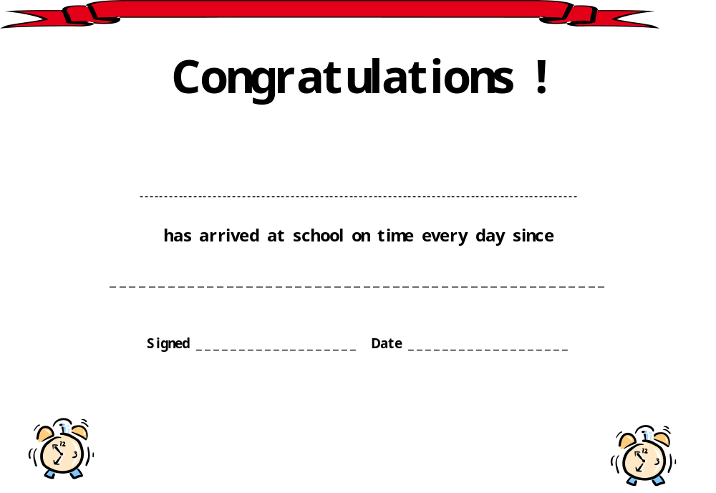
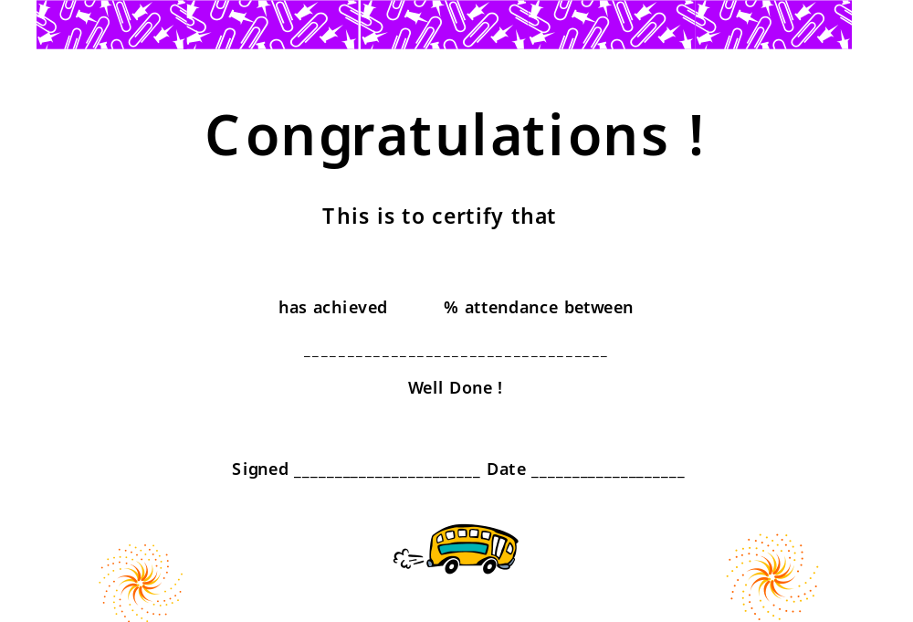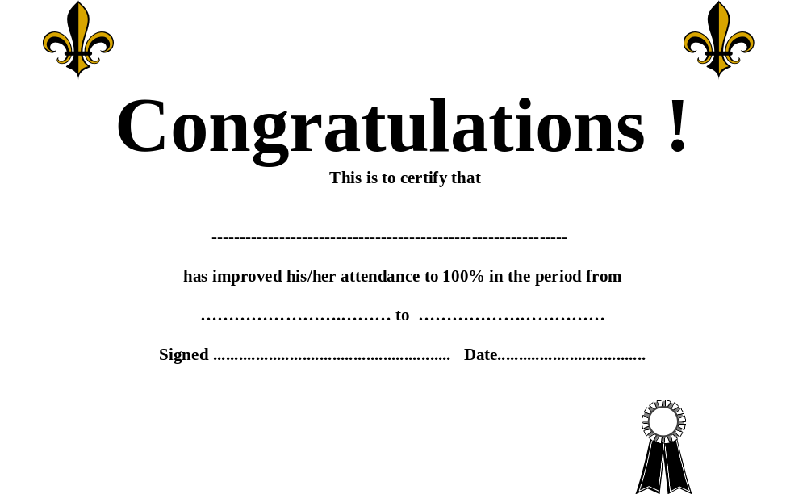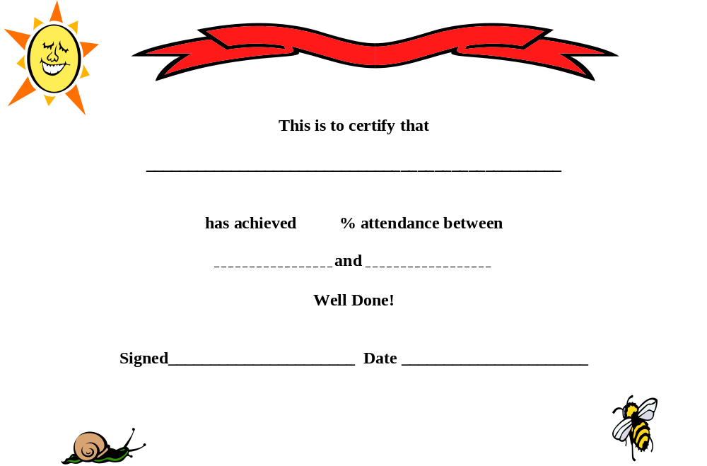

APPENDIX B

FAMILY HOLIDAYS IN TERM TIME
AND
HOLIDAY AUTHORISATION CALCULATION CHART

This section can also be found at: http://www.thegrid.org.uk/info/welfare/attendance.shtml
Hertfordshire County Council

Children’s Services

FAMILY HOLIDAYS

(During Term Time)

AND EXTENDED TRIPS OVERSEAS

Notes and Guidance for Schools

Produced by the Integrated Services for Learning (ISL) Behaviour & Attendance Central Team

February 2011 (3rd update)

FAMILY HOLIDAYS DURING TERM TIME

The conditions under which leave of absence for a holiday during term time may be granted are laid down in regulation 7 of ‘The Education (Pupil Registration) Regulations 2006 and sections 62 – 68 of the DfES publication Keeping Pupil Registers.

Regulation 7 states that:

“(3) Subject to paragraph (4), a pupil may be granted leave of absence from the school to enable him to go away on holiday where —
(a) an application has been made in advance to the proprietor by a parent with whom the pupil normally resides; and
(b) the proprietor, or a person authorised by the proprietor in accordance with paragraph (1), considers that leave of absence should be granted due to the special circumstances relating to that application.
(4) Save in exceptional circumstances, a pupil shall not in pursuance of paragraph (3) be granted more than ten school days leave of absence in any school year.”

Permission is granted or not in accordance with arrangements made by the governing body of the school.

No parent can demand leave of absence for the purposes of a family holiday as of right.

Only in ‘exceptional circumstances’ may the amount of leave granted exceed in total more than ten days in any school year.

Schools should explore with parents why such leave of absence is necessary.

Each request for holiday absence should be considered individually. It is the responsibility of the Head Teacher and governors to decide whether or not to grant leave of absence. When making the decision the following factors should be considered:

- the amount of time requested
- age of the pupil
- the pupil’s general absence/attendance record
- proximity to SATs and public examinations
- length of the proposed leave
- pupil’s ability to catch up the work
- pupil’s educational needs
- general welfare of the pupil
- circumstances of the request
- purpose of the leave
- frequency of the activity, and
- when the request was made.

The procedure for requesting leave of absence should be available to parents. Clear advice should be included within the school’s prospectus and school attendance policy. Parents should be made aware that:

- holidays in term time are not a right and will not automatically be granted.
- leave will be granted only where proper procedures have been followed and permission given.
- it remains the discretionary power of the Head Teacher to authorise leave of absence.

When leave of absence has been granted the absence should be recorded as authorised, using the appropriate register symbol:

F – extended Family Holiday (agreed)
H – Family Holiday (agreed)

If parents take the child away without permission, or fail to apply for permission in advance of the holiday the absence should be recorded as unauthorised. If the pupil is kept away for a period in excess of the time agreed with the school the extra time should be treated as ‘unauthorised’ absence. The appropriate register symbol in both these circumstances is:

G – Family Holiday not agreed (or days in excess of agreement)

The form ‘Application for Leave of Absence for Annual Holiday’ – which schools may wish to use is included in these notes.

Also included is a ‘Holiday Authorisation Calculation Chart’ which schools can use to help to ensure that all applications are dealt with in a consistent way.

EXTENDED TRIPS OVERSEAS DURING TERM-TIME

In deciding whether to grant extended leave of absence, schools should consider the particular circumstances of each individual case. It is important that schools show an understanding of the parents’ perspective whether or not they are able to agree to the request for absence.

Schools should ensure that all parents are aware of the school’s attendance policy.

When deciding whether to grant leave of absence schools may wish to consider the following:

- A visit involving family overseas has an entirely different significance than the normal associations with a holiday.
- Visits may be very important in terms of children’s identity and self-esteem as they grow up.
- Parents may feel that the reasons for their visit outweighs the importance of their child’s uninterrupted attendance at school – maintaining family links in extended family situations may involve greater significance and greater pressures in some cultures than it does currently in many western cultures.
- The reasons for parents making a visit may be, for example, family illness or bereavement. It is less easy for parents to undertake these normal and necessary activities where long distances and high costs are involved.
- If it is possible to include school holidays in the leave of absence so as to limit the amount of term time the pupil is absent.
- Governing bodies may wish to consult with local minority groups.

If leave of absence is agreed schools should consider:

- Explaining the work the pupil will miss, how it can be made up on return and how the parents could help the pupil.
- Whether work can be given to the pupil while he or she is away.
- Preparing a study pack.
- Asking the pupil to make notes and observations on a form/tutor group topic.
- Going through any work done by the pupil on return.
- Sharing experiences in a positive way with the form/tutor group and teacher on return.

Parents should be informed of the regulation on removal from the school roll if the pupil does not return on the agreed date. Parents should be asked to contact the school if the return is delayed. Schools should ensure that they have a contact number in the UK so that they can make enquiries if the pupil does not return at the agreed time.

Failure to return on the agreed date

When granting leave of absence for an extended trip overseas, schools should ensure they have a date when the pupil will return to school. Regulation 8 (f) details in what circumstances pupils may be removed from roll if they do not return by the agreed date.

The Education (Pupil Registration) Regulations 2006

Regulation 8 (f) states that this applies -

‘In the case of a pupil granted leave of absence exceeding ten school days for the purpose
of a holiday in accordance with regulation 7(3), that —
(i) the pupil has failed to attend the school within the ten school days immediately
following the expiry of the period for which such leave was granted;
(ii) the proprietor does not have reasonable grounds to believe that the pupil is unable to attend the school by reason of sickness or any unavoidable cause; and
(iii) both the proprietor and the local education authority have failed, after reasonable enquiry, to ascertain where the pupil is;

OTHER CIRCUMSTANCES

Occasionally, parents/carers may advise schools that they need to take their child away from school for a period of time and that they do not know the date of return. An example might be when a close relative, living at a distance from the family, is dying.

Schools should consider whether these absences should be regarded as ‘family holidays’ or as an ordinary absence from school and should always make sure they have contact details for the parents, including an address to which letters can be sent at their destination. An email address is also useful.

If they are to be regarded as an absence, not a holiday, the school should decide if the absence can be authorised. Code ‘C’ (Other authorised circumstances (not covered by another appropriate code/description)), is for exceptional occasions which may warrant leave of absence. Schools should consider each request individually taking the following into account:
- the nature of the event for which leave is sought;
- its frequency (is it a one-off, or likely to become a regular occurrence?);
- whether the parent gave advance notice; and
- the pupil’s overall attendance pattern.
Examples might include special occasions such as attending the wedding of a family member, family bereavement, prison visits.
If the absence is prolonged, schools should read Statutory Instrument No. 1751 The Education (Pupil Registration) (England) Regulations 2006. These give detailed information about when a pupil may be deleted from the Admissions Register. Schools should discuss this with their Attendance Improvement Officer.

STRATEGIES FOR REDUCING HOLIDAYS DURING TERM TIME

- Schools and the Local Authority should actively discourage holidays during term time.

- The school’s Attendance Policy should state that holidays during term time are not acceptable.

- Parents should be given a clear message at every opportunity, e.g. at parents evening, in newsletters, school brochure and bulletins, about taking holiday in term time.

- Parents should be informed of dates when leave of absence will not be granted, eg, school examinations or SATs. It will be helpful to send the school calendar to parents at the start of the term so that they are aware of term times and important dates.

- Parents requesting holidays could be invited into school to discuss the proposed absence and implications for their child of missing school time.

- Schools may wish to agree joint policies within their local area to provide consistency. This will ensure parents are aware of practice and ensure that schools are operating on the same basis with attendance figures.

- Term time holiday absence should be recorded on the pupil’s report.

- To identify the extent of the issue keep a record of the amount of absence taken for holidays. This could be published by the Governors in their report to parents, giving the absence figure excluding holidays during term time.


APPLICATION FOR LEAVE OF
ABSENCE FOR ANNUAL
HOLIDAY
As a parent or carer, you should fill in this form if you want to take your child out of school during term time to go on an annual holiday.

After completing the form, please return it to the Headteacher of your child’s school no less than 2 weeks before the date when you want the period of absence to start.

The conditions under which leave of absence for term-time holidays may be granted are contained in Reg. 7 of The Education (Pupils Registration) Regulations 2006 and Sections 62 - 68 of the DfE publication Keeping Pupil Registers 2008.

Schools may decide whether or not to authorise leave of absence for a family holiday. Parents or carers should not expect such leave to be granted as of right. Permission will not be given if it is applied for after the holiday has taken place.

Normally, a pupil shall not be granted more than 10 school days leave of absence in any academic year.
I request that _________________________
(Name of child)

be granted leave of absence from

___________________________ (Name of school)

From _________________ To ________________ 20__
in order to take part in an annual holiday

______________________________ ___________
(Signature of Parent Carer) (Date)

Please read the notes on the back of this form concerning ‘Failure to return on the agreed date’

Failure to return on the agreed date

When granting leave of absence for an extended trip overseas, schools should ensure they have a date when the pupil will return to school.

DELETION FROM THE ADMISSION REGISTER
The Education (Pupil Registration) Regulations 2006 -

Regulation 8 (f), states that a pupil may be removed from the school roll if the following applies -

(f) in the case of a pupil granted leave of absence exceeding ten school days for the purpose
of a holiday in accordance with regulation 7(3), that —
(i) the pupil has failed to attend the school within the ten school days immediately
following the expiry of the period for which such leave was granted;
(ii) the proprietor does not have reasonable grounds to believe that the pupil is unable to attend the school by reason of sickness or any unavoidable cause; and
(iii) both the proprietor and the local education authority have failed, after reasonable enquiry, to ascertain where the pupil is;

Family Holiday Requests during Term Time

The Head Teacher has the discretion to grant up to ten days authorised absence for family holidays in a school year. However, each application will be considered individually taking into account factors such as the timing of the holiday and the pupil’s attendance. For example, a pupil with an otherwise perfect attendance record will achieve a maximum of 94.7% attendance if s/he goes on a ten day holiday during term time. One way of managing this is by using the Holiday Authorisation Calculator (see below). The legislation states that,

“(3) Subject to paragraph (4) a pupil may be granted leave of absence from the school to enable him to go away on holiday where –

- An application has been made in advance to the proprietor by the parent with whom the pupil normally resides; and
- The proprietor, or a person authorised on authorised by the proprietor in accordance with paragraph (1), considers that leave of absence should be granted due to the special circumstances relating to that application.

(4) Save in exceptional circumstances, a pupil shall not in pursuance of paragraph (3) be granted more than ten school days leave of absence in any school year.”

The Education (Pupil Registration) (England) Regulations 2006.

In brief, this means that:
- Parents CANNOT demand a leave of absence as an automatic right.
- Parental requests MUST be made in advance.
- Schools CANNOT apply blanket policies to approve/reject all applications
- All requests MUST be considered on their own merits.
- Extended periods of absence will be granted ONLY in exceptional circumstances.

Holiday Authorisation Calculator

The power to authorise/unauthorise a leave of absence belongs to the Head Teacher. In order to ensure equity within and between schools, decisions on whether or not to authorise a leave of absence for family holidays could be guided by the use of the Holiday Authorisation Calculator. This does not remove the Head Teacher’s prerogative to authorise holiday in exceptional circumstances.

Procedure

Parent/ carer should complete a holiday request form and submit this to the school at least two weeks prior to the intended period of absence; school will respond to the request within one week. If school is aware of any difficulties that may preclude a request form being completed, appropriate support should be offered to the parent/carer.

The Holiday Authorisation Calculation Chart should be used to guide the Head Teacher’s decision on whether or not to authorise the requested leave of absence.

If the total score is 6 or less, holiday leave may be authorised.
If the total score is 7 or more holiday leave should not be authorised. However, the Head Teacher may be aware of exceptional circumstance which would warrant approving holiday leave and this should be recorded on the form.

If a pupil has already taken ten days’ holiday leave in the same academic year, further holiday leave should not be authorised.

If the Local Authority has begun legal proceedings, holiday should not be authorised and this should be recorded on the form.

Parents should be made aware (perhaps in the School Handbook) that holidays which have not been agreed in advance will lead to the pupil being marked with unauthorised absences and that this may be referred to the Local Authority for consideration of a Penalty Notice or other action.

A letter confirming that the request has been authorised /denied should be sent to the parent/carer, with a copy of the Holiday Authorisation Calculation Chart within one week of receipt of the holiday request.

Holiday Authorisation Calculation Chart

Name of pupil …………………..………… .School……………………………
Year……………………………………….

The merits of each individual request should be evaluated by providing answers to ALL the following questions and scoring accordingly.

(*Where the holiday already taken in the current academic year exceeds the DfE guideline i.e. “maximum of 10 days in any academic year”, any further requests should NOT be authorised.)

 | Points possible |  |  | Points
When is the holiday planned for? September is the beginning of the academic year and full attendance is vital if pupils are to establish themselves academically and in terms of friendship groups. | September = 2pts
Pupil’s attendance level is?  (up until Autumn half term use the % figure from the previous year.) | Less than 70% = 6 pts  70% to 80% = 5 pts  80% to 85% = 4 pts  85% to 93% = 3 pts  More than 93% = 2 pts
How close is the pupil to a SATs assessment or other examination? | Non-SATs/Exam year = 1 pt  More than 16 wks = 1 pt  8 – 16 weeks = 2 pts  2 – 8 weeks = 3 pts  Less than 2 weeks = 4 pts
How much holiday leave has already been taken in current academic year?* | 8 or more days = 4 pts  5 to 7 days = 3 pts  2 to 4 days = 2 pts  1 to 3 days = 1 pt
Subtotal
Any special mitigating or aggravating circumstance which indicates that a holiday should be authorised or not authorised contrary to score indicated above. |  | Subtract or add 2 points
Details of mitigation/aggravation

Total
Leave for family holiday where the total is 7 or more should not be authorised

The only exception to the above may be where there are, in the opinion of the Head Teacher, ‘exceptional circumstances’ (including religious and cultural considerations; add comment in mitigation/aggravation box). If the Local Authority has begun legal proceedings holiday should NOT be authorised.

DELETE WHERE APPROPRIATE:- REQUEST APPROVED/ REQUEST DENIED

Completed by ………………………………………………… Date …………………………

APPENDIX C

QUESTIONNAIRE FOR PARENTS’ EVENINGS

ATTENDANCE QUESTIONS

For what reasons could an absence from school be authorised?

- Holiday
- Birthday
- Buying school shoes

95% attendance over a school year is:

- One day off a week
- One day off a fortnight
- One day off a month
- One day off every two months

Who authorises absences from school?

- The Headteacher of the school
- The GP
- The Parent

Does a late arrival count as an absence?

- No, only if a pupil is absent for a whole morning or afternoon session
- Yes, even if they are only 5 minutes late
- Yes, if they arrive after registers close.

Answers for Questionnaire are:

- 1 - holiday (but not always authorised). The other absences would be unauthorised.

- 3 - one day off a month. 90% attendance means the pupil has a day off each fortnight. Would employers accept this level of absence?

- 1 - the Headteacher of the school who usually delegates this authority to form tutors

- 3 – Yes if they arrive after registers close – what time is that for your school?

APPENDIX D

PSHE LESSON
PSHE – ATTENDANCE

Sample Session 1

Aim – to gauge pupils’ attitudes to attendance.

Last term, ? pupils had 100% attendance and received a certificate.

Who got a certificate?

We want to double that this term.

Let’s think of some reasons why you might not come to school, reasons which stopped the rest of you getting a certificate.

- Not well (if Mum or Dad are not well, school can help you keep in touch with them through the day so you know they are OK)
- Family holiday
- Dentists/doctors appointment (should make out of school time)
- Bullying (if bullying is raised, remind pupils they should come back to school so it can be sorted out. It is not fair that the bully can carry on coming to school without retribution)

Now let’s think of some reasons for being in school:
- To learn!
- To see my friends
- Some lessons are good fun
- To get good exam results
- To get a good job
- I can talk to teachers about what career I might have
- I can talk to pastoral staff if I am having problems outside school
- To enable me to go to University
- School dinners are tasty
- To get some exercise
- School trips take me to places I wouldn’t otherwise go
- Having to be somewhere on time every day is good practice for when I have a job
- Parents get a break
- It stops me getting bored
- I get a break from my brothers and sisters
- I sleep better because I’ve been busy
- IT’S THE LAW!

So there are many more reasons to be in school than not to be in school. If you attend well, it’s a win/win situation!

Sample Session 2

Aim – to provide visible evidence of good attendance and encourage pupils to be the ‘last person standing’

- Ask all form/tutor group to stand up
- Ask all those who have had a holiday, even if for one day to sit down – discuss reasons why holidays in term time are not a good idea – see previous sections
- Ask all those who have had a day’s sickness to sit down – discuss whether they could have come into school and may have started to feel better; when they should definitely not be in school (sickness and diarrhoea, hospital stays), what would happen if other people had lots of days off for sickness (e.g. doctors and nurses, police, teachers, air traffic controllers, refuse collectors) Attending school regularly is good practice for being an adult and going to work regularly.
- Ask all those who have had a doctor’s or dentist’s appointment which has been during school time to sit down – discuss whether this needed to be made in school time. Acknowledge that sometimes this is necessary as there are no ‘after school appointments’ but they should attend school before or after the appointment.
- Ask all those who have had a day off for other reasons e.g. wedding, to sit down. Discuss what might be special or important enough to mean that you had to miss school e.g. funeral, wedding of close family member, sibling or parent’s graduation, any very special event that will never happen again. This does not include birthdays, shopping, meeting relatives from the airport.
- Who is left standing? They should receive a round of applause! Does that include the teacher?

As a follow on activity, pupils could set targets for their own attendance and plan how they are going to meet them.

APPENDIX E

LATE PATROLS – GOOD PRACTICE GUIDELINES

Late Patrols - Good Practice Guidelines

Introduction:

School Gate Patrols can be a useful way of targeting punctuality issues within the school setting, in conjunction with other methods to support and improve whole school attendance and punctuality.

Aims:

- To improve punctuality of pupils arriving for school each day.
- To make pupils and parents / carers aware of the importance of good punctuality and the impact this has on learning and achievement.
- To highlight issues of poor punctuality.
- To target specific areas e.g. lateness on mornings when assembly takes place,
- To work with pupils and parents / carers as appropriate to improve punctuality.
- To support school strategies to improve punctuality and attendance.

Issues to Consider:

School Gate Patrols can be useful and the following issues should be considered:

- Parents should be told that School Gate Patrols are about to happen.

- Who will undertake the Gate Patrol? The Attendance Improvement Officer, if involved, must be accompanied by either the Headteacher or a senior member of school staff, to demonstrate a joint approach and to ensure that those pupils who have genuine issues are not approached. All staff must wear ID badges.

- When will the Gate Patrol take place? – it is important to ensure that Gate Patrols are well planned, and that the times chosen will highlight the importance of good punctuality (e.g. from 10 minutes prior to the start of school to 20 minutes after the start of school).

- Where will the Gate Patrol take place? – where will staff stand to ensure that pupils are seen and can be spoken to easily? At the school gate, on the path leading into school, at the school door (dependent on number of entrances used), outside a particular targeted form room or Key Stage area?

- How frequently will the Gate Patrol take place? – maybe several occasions close together initially, and then further ad hoc occasions to remind pupils of the importance of punctuality.

- Who will speak to pupils– will this be the role of the staff member or the AIO? Plan what will be said in advance, to ensure that messages are consistent and appropriate.

- What follow up will be required? – Agree who will deal with any issues that require follow up, e.g. letters to parents / carers, punctuality awards for improvement in schools. It is good practice to follow up with an article in the school newsletter, or letter to parents explaining the piece of work.

APPENDIX F

SAMPLE SPONSORSHIP LETTERS

Dear Sir,

Helping …………………………… Secondary School achieve excellent attendance

Over this academic year …………. School is giving a high priority to improving school attendance and good punctuality. A number of initiatives have been implemented in the school, to raise both pupil and parent awareness of this issue and the benefits of good attendance for the school and the wider community.

One initiative involving pupils across the school is a competition between the form/tutor groups for the best attendance/most punctual form/tutor group. We hope to be able to give prizes to every form/tutor group for any improvement made in this area. We would like to give every form/tutor group a voucher, during a school assembly, which pupils will then decide how they ‘spend’.

As you are aware funding within schools for this type of activity is limited. That is why we are approaching local businesses to request donations of monies or vouchers which can be used as prizes for the pupils.

If you wish to make a donation, or if you have any further enquiries, please do not hesitate to contact me.

Thank you in anticipation,

Dear Sir,

Helping …………………………… Secondary School achieve excellent attendance

Over this academic year …………. School is giving a high priority to improving school attendance and good punctuality. A number of initiatives have been implemented in the school, to raise both pupil and parent awareness of this issue and the benefits of good attendance for the school and the wider community.

One initiative which we are using is to award small prizes to those pupils who have achieved 100% attendance, or have very much improved attendance or punctuality. These are calculated on a monthly/half termly/termly basis and the prizes are presented in assembly, along with a certificate.

As you are aware funding within schools for this type of activity is limited. That is why we are approaching local businesses to request donations of monies or vouchers which can be used as prizes for the pupils.

If you wish to make a donation, or if you have any further enquiries, please do not hesitate to contact me.

Thank you in anticipation,

APPENDIX G

ABSENCE DATA

HERTFORDSHIRE AND NATIONAL

Secondary School Absence Data – taken from Statistical First Release
(Oct 10) and based on Autumn and Spring Terms for each year

Secondary

Hertfordshire

Year | Persistent | Authorised | Unauthorised | Total
2006/07 | 5.9% | 6.25% | 1.09% | 7.34%
2007/08 | 5.4% | 5.80% | 1.00% | 6.70%
2008/09 | 4.8% | 5.75% | 1.00% | 6.75%
2009/10 | 3.8% | 5.45% | 0.98% | 6.42%

National

Year | Persistent | Authorised | Unauthorised | Total
2006/07 | 6.9% | 6.30% | 1.46% | 7.76%
2007/08 | 6.4% | 5.86% | 1.41% | 7.27%
2008/09 | 5.6% | 5.79% | 1.44% | 7.23%
2009/10 | 4.5% | 5.44% | 1.40% | 6.84%

*Persistent Absentees have 80% attendance or less

APPENDIX H

ACTION PLAN


Action Plan –Secondary

Date of Action Planning Meeting:
Present:
Name of Pupil: | Form Tutor:
Name of Parent(s): | Contact no. of parent(s):
Year Group: | Current Attendance:

Reasons for Absence: | Illness
 | Friends/Peers
 | Teachers
 | Lessons
 | Getting to school
 | Family
 | Other

Strategies to improve attendance (See over):

Section 7 of the Education Act 1996 states:
The parent of every child of compulsory school age shall cause him to receive efficient full-time education suitable -
(a) to his age, ability and aptitude, and
(b) to any special educational needs he may have, either by regular attendance at school or otherwise

If parents do not carry out this responsibility, they may be prosecuted. Depending on the offence, the maximum fine per parent, per child is £1000 or £2500 and/or 3 months imprisonment.

Target Attendance for period ending:
Target Attendance for period ending:
Target Attendance for period ending:
Target Attendance for period ending:
Review: dates:

Signature: Parent………………………Student…………………………..School…………………….
POSSIBLE STRATEGIES TO IMPROVE ATTENDANCE

 | Strategy | Comments on strategy | Dates  (from/to)
 | Parents
 | Alarm clock/get up earlier
 | Change in bedtime routine
 | Do not book holidays in term time
 | Provide rewards/privileges for good attendance
 | Young person to visit GP
 | Make more time to talk to young person
 | Provide assistance with getting to school
 | Bring into school and ensure meets member of staff
 | Phone school if absent or suspect may not arrive
 | School
 | Attendance report
 | Mentor/link person
 | Buddy
 | Place of safety
 | Special responsibility
 | Discussion with form/subject tutor
 | Modification of registration
Modification of curriculum/
timetable
 | Change of form/tutor group
 | Extra-curricular activities
 | Additional Careers advice
 | Work Experience
 | Targeted first day response
 | Meet with school nurse
 | Youth Connexions input
 | Customised reward/privilege for good attendance
 | Student
 | Make sure you are ready for school
 | Complete own attendance chart
 | Discuss any problems as soon as possible with member of school staff
 | Keep diary – bullying, difficulty with lessons etc.

APPENDIX I

SIMS ATTENDANCE REPORTS
Official Registers

Use:
- this is currently a statutory requirement
- must be printed at the end of each month and kept for 3 years

To access this report on SIMS:
- Reports
- Attendance
- Whole Group Pupil Reports
- Official Register
- Select Group Type
- Print

Individual pupils’ attendance in detail

Use:
- during any meeting with parents, to show attendance for their child for whole school year, day by day, with codes
- to send in letter to parents to demonstrate why pupil’s attendance is causing concern

To access this report on SIMS:

- Reports
- Attendance
- Individual Pupil Reports
- Registration Certificates
- Individual Students
- Search
- Select
- Print

Less than or more than ?% attendees in the whole school, year group or form/tutor group

Use:
- to identify pupils causing concern (below 80/90%),
- to identify pupils with 100% attendance who will receive a certificate

To access this report on SIMS:
- Reports
- Attendance
- Selected pupil reports
- Percentage attendance report
- Group type (e.g. year group)
- Less than … or more than …. Or exactly 100%…..
- By name
- Select dates
- Search
- Select the ones (or groups) you want – use CTRL to select more than one
- Print
- OK

Whole school attendance to date by year group/form/tutor group

Use:
- to identify attendance for each year group/form/tutor group if rewards are being given for the group with the best attendance
- to compare the attendance of different years/form/tutor groups and consider why there may be differences e.g. are some registers being closed before the rest of the school?

To access this report on SIMS:
- Reports
- Attendance
- Group reports
- Group session summary report
- Check dates
- Group type – year group or registration group– select all using CTRL (or restrict to years 7 – 11)
- Search
- Print

Pupils with a specific code

Use:
- to identify those pupils who have had an absence for a particular reason e.g. M for medical or dental appointments during school time or for a holiday

To access this report on SIMS:

- Reports
- Attendance
- Selected pupil reports
- Pupils with chosen code report
- Codes – take out present and select codes to look at e.g. G F H
- Check dates
- Search
- Print

Whole school showing all codes

Use:
- to identify if any type of absence is high across the whole school e.g. holidays in term time

To access this report on SIMS:

- Reports
- Attendance
- Group reports
- Group analysis by code
- Group type – whole school
- Check dates
- Restrict dob range (to take out sixth form, if required)
- Search
- Print

Minutes late

Use:
- to provide date, session (am/pm) and number of minutes late for a pupil and the total minutes lost over a period of time

To access this report on SIMS:

- Reports
- Attendance
- Selected Pupil Reports
- Minutes late
- Group type (e.g. whole school)
- Search
- Print

Comments on minutes late

Use:
- to provide comments relating to a pupil’s late arrivals in school

To access this report on SIMS:

- Reports
- Attendance
- Selected Pupil Reports
- Comments
- Group type (e.g. whole school)
- Search
- Print

Registration Certificates ON SCREEN for a selected group e.g. less than 90% in a form/tutor group

Use:
- during an AIO Consultation visit, to check individual pupils’ attendance without printing registration certificates.

- Reports
- Attendance (or go into Lesson Monitor and choose attendance)
- Individual pupil
- Registration Certificate
- Check dates
- Group type – Individual Students
- Search
- Choose student, click and keep CTRL pressed,
- Print
- OK (output to web browser)
- Click on Registration Certificate at bottom

Individual pupil’s overall attendance

Use:
- to provide attendance totals (sessions) for end of year reports

To access this report on SIMS:

- Reports
- Attendance
- Whole Group Pupil Reports
- Pupil Analysis by Attendance Category
- Make Selections
- Check dates
- Search
- Print

Individual pupil’s or other groupings attendance by session in week

Use:
- can identify if a pupil is absent at the same time each week e.g. Monday (after weekend with parent with whom they do not normally live?) or on days when PE or swimming takes place.

To access this report on SIMS:

- Reports
- Attendance
- Whole Group Pupil Reports
- Pupil Analysis by session in week
- Make selections
- Search
- Print

Individual pupil’s or other groupings attendance by code

Use:
- to show by percentage or number of sessions how absences are categorised across the school by absence code
- to show by percentage or number of sessions how an individual’s absences are categorised by code

To access this report on SIMS:
- Reports
- Attendance
- Whole Group Pupil Reports
- Pupil Analysis by attendance code
- Make selections e.g. whole school, registration group, year group
- Check dates
- Search
- Print

Whole school attendance in all sessions of the week

Use:
- to show by percentage whole school attendance for each session of the week. If a particular session is shown to be low, school can seek ways to improve it

To access this report on SIMS:
- Reports
- Attendance
- Group Reports
- Group Analysis
- Session in Week report
- Check dates
- Make selections – e.g. present only, percentage
- Search
- Print

To create User Defined Group

Use:
- To create a list of poor attenders whose progress is checked frequently

To create and access this list on SIMS:
- Focus
- Groups
- User Defined Group
- New
- Group Description and short name - complete
- Active state – Active
- Check academic year
- Action button (in ‘membership’) and add member
- Group Type – Year Group, School tier (cannot have whole school)
- Search (next to group). This provides all tiers
- OK
- Search again
- OK
- Save

Then access the User Defined Group via reports.

