Guidance on schemes of delegation

For academy trusts

Updated November 2020

National Governance Association
The National Governance Association (NGA) is the membership organisation for governors, trustees and clerks of state schools in England.

We are an independent, not-for-profit charity that aims to improve the educational standards and wellbeing of young people by increasing the effectiveness of governing boards and promoting high standards. We are expert leaders in school and trust governance, providing information, advice and guidance, professional development and e-learning.

We represent the views of governors, trustees and clerks at a national level and work closely with, and lobby, UK government and educational bodies.

www.nga.org.uk

Contents
Introduction to the guidance 3
The status of the scheme of delegation 4
Format and structure 5
Features of an effective scheme of delegation 5
The standard model of delegation 6
Features of the standard model 6
Detailed roles and responsibilities 7
Variations 9
Delegation and decision making in an academy trust 10
Appendix 1 - Structure diagrams for variations on the standard model 13
Appendix 2 - Example terms of reference for academy committees (LGBs) 14
Appendix 3 - Example of a meeting schedule for academy committees (LGBs) 15
Appendix 4 - Example of an agenda for academy committee (LGB) meetings 16

NGA’s model schemes of delegation
NGA first produced its model schemes of delegation in 2016. These were updated in 2017 and since then have stood the test of time, with many trusts continuing to use them as a valuable source of information for determining their approach to delegation within their trust structure.
NGA’s ongoing work with trusts is included in the June 2019 publication of the research paper Moving MATs forward: the power of governance. Among a range of other recommendations, it urged trust boards to develop an accessible and usable scheme of delegation which carefully considers the role applied to the local tier with effective communication channels developed between each layer of governance. In other words, there is evidence that the issue of what is delegated is still being worked out.
These findings, along with what we continue to learn from our work with trusts, has fed into this review of the schemes of delegation. As a result, we have taken a slightly different approach, and instead of publishing a number of models, we have opted for a single guidance document which outlines different options for consideration by trusts, depending on their context, or for those with schools in a variety of circumstances.
We hope that you find the guidance useful.

A word about single academy trusts
As single academy trusts do not have a separate layer of governance at school level, any scheme of delegation will be simpler and more straightforward as it will only need to make clear what is delegated to board committees and to the executive. For this reason, many single academy trusts do not have a scheme of delegation, instead relying on their committee terms of reference to identify where governance functions are exercised, and who makes decisions. However, this guidance can be used to inform single academy trusts on the roles and responsibilities of members, trustees and board committees, and how these might be organised within their trust.

Introduction to the guidance
A multi academy trust’s board of trustees is accountable in law for all major decisions about all the schools within the trust. However, this does not mean that the board is required to carry out all the trust’s governance functions and many functions can and should be delegated elsewhere, including to the CEO, the board’s committees, and to academy committees, often known as local governing bodies (LGBs). It is vital that the decision to delegate a function is made by the full board of trustees and is recorded. Without such delegation, the individual or committee (board or academy) has no power to act.
The principle governing document in trusts is the articles of association. The articles set out the charitable purpose of the trust, providing a framework for trusts to act within both company and charity law. They will not however include the specific detail of the trust’s chosen governance structure and how governance functions have been delegated. This is why it is critical that trusts agree a scheme of delegation that explicitly establishes who carries out which governance function and can therefore make the decisions associated with that function.
A scheme of delegation is not an optional extra – it is an essential requirement for effective governance and clear decision making. As a document, the scheme of delegation should be as simple and systematic as possible, so that the members, trustees, board committees, academy committees (LGBs), and executive leaders are all clear about their roles and responsibilities within the governance structure.
It is important that the scheme of delegation is visible to all, both within and beyond the trust, so that it is clear how the governance structure and lines of accountability work. This is why the scheme of delegation must be published on the trust’s website, as well as all of its schools’ websites.
When considering any guidance on schemes of delegation, it is important to bear in mind that the model that you adopt must be appropriate for your trust. Governing and managing groups of schools is complex - hence this guidance is designed to demonstrate how a scheme of delegation need not detail every single governance function, but seeks to demonstrate the principles which determine the lines of accountability so that it is clear where certain functions and key decision making lies.

Some points to note:
- Academy trusts should maintain a clear distinction between accountability through governance (i.e. by the trust board and its committees) and accountability through line management (i.e. by executive leaders); you will find examples of mixed accountability in the variations to the standard model of delegation illustrated in this guidance, i.e. where both governance and line management are being utilised.
- NGA takes the view that there should be clear separation between the layers of governance which means that the individuals making up one tier of the governance structure of the organisation are not the same as another tier; in other words, ideally, members should not also be trustees.
- Academy trusts with academy committees can choose what they call these committees. Many opt for local governing body (LGB) with those on the LGB being known as governors. However, they should be clear that this terminology is not used in the same sense as when it is used in maintained schools, where governing bodies and governors act in accordance with school governance regulations.
- The overarching scheme of delegation should not be confused with the written scheme of delegation of financial powers referred to in the Academies Financial Handbook.

The status of the scheme of delegation
The scheme of delegation is a key governance document because without it, it is not clear how accountability and decision-making works within the trust. This is why the Academies Financial Handbook (AFH) requires it to be published on the trust’s website (AFH 2020 para 2.50).
It is especially important that maintained schools joining academy trusts take time to understand the trust’s scheme of delegation so that they are clear about the trust’s approach to local governance and which functions are delegated. Many trusts supplement the scheme of delegation with terms of reference for their academy committees (LGBs), so it is clear how these are constituted. For an example, see appendix 2.
As with all committees, the trust board has the power to change the constitution and powers of its committees at any time, and this includes the membership of those committees too.

Format and structure
While schemes of delegation will vary from trust to trust, there are some basic principles which it is helpful to consider. NGA’s guidance aims to clarify where governance functions and decision-making lie, so that lines of accountability are clear. Our guidance includes:
- a structure diagram which shows the layers of governance, basic functions, and lines of accountability
- a narrative description of the roles and responsibilities of each layer of governance
- a grid format, with columns for each layer of governance which indicates clearly who within the trust is responsible for each function and the associated decision making. The grid is in four key areas to reflect both the governance framework and the three core functions of the governing board:
- The governance framework:
        - People
        - Systems and structures
        - Reporting
- Being strategic
- Holding to account
- Ensuring financial probity
This guidance does not use the legal language associated with articles of association. This is because a scheme of delegation is a trust board document (as are committee terms of reference), and as such can be revised and adapted in response to the trust board’s context and circumstances. It is, however, important to ensure that all those involved in governance in the academy trust are consulted on and made aware of any changes and understand what these changes will mean in practice.
Features of an effective scheme of delegation
An effective scheme of delegation will:
- reflect the trust’s ethos, promoting a positive climate and a culture of honesty, transparency, and accountability for the benefit of all stakeholders
- ensure the executive leadership is clear about which decisions the trust board retains, and the extent of executive powers
- be clear about who appoints and performance manages the chief executive, other senior executives, and the schools’ headteachers
- identify where the trust board retains responsibility for:
- determining policy
- management of risk
- oversight of budgets and financial management
- oversight of educational performance

The standard model of delegation
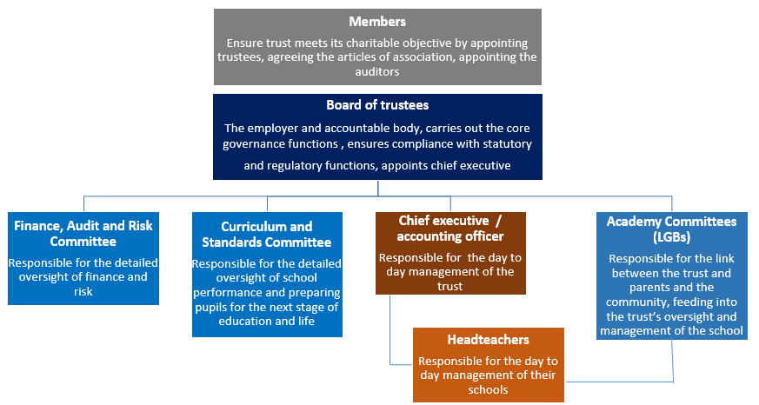

Features of the standard model
This model of delegation has become by far the most common governance structure in MATs. It features:
Three clear layers of governance:
- members
- trustees
- committees and individuals
It makes clear that:
- The members have a limited yet distinct and vitally important role.
- The board of trustees is responsible for the core governance functions.
- The board of trustees appoint the chief executive (CEO), to whom it delegates responsibility for the conduct and performance of the trust, including the performance of the schools within the trust, and for its financial management.
- The board constitutes committees for finance, audit and risk, and for curriculum and standards; these look in detail at resources and risk, and progress and attainment across the trust.
- The board also constitutes academy committees (LGBs) to provide links to parents and the community, as well as for providing additional scrutiny of how the trust is managing its schools. These may or may not have formal delegated governance functions or decision-making powers.
- It should also be clear from which tier within the governance structure that panels are convened; this should include formal complaints panels, reviewing pupil exclusions and dealing with disciplinary matters.

Detailed roles and responsibilities

The role of the members
- The members of the trust are guardians of the governance of the trust and must ensure it carries out its charitable objective.
- There must be at least three members, although the DfE prefer at least five; members are not permitted to be employees of the academy trust.
- The members agree the trust’s articles of association, appoint trustees and appoint the trust’s external auditors.
- The members should receive information about the trust’s business and receive the annual report and accounts. If they have concerns that the trust is not carrying out its charitable objective, members should remove trustees that are failing to fulfil this responsibility.

The role of the trustees
- The trust is a charitable company and so trustees are both charity trustees (within the terms of section 177(1) of the Charities Act 2011) and company directors (within the terms of the Companies Act 2006).
- Trustees are bound by both charity and company law so the terms ‘trustees’ and ‘directors’ are often used interchangeably. NGA uses the term trustee as it avoids the possible confusion caused when executive leaders are called directors but are neither company directors nor trustees. The use of trustee also serves to highlight the overarching charitable purpose of the organisation, distinguishing it from other directorships that may be held in the private sector.
- Trustees are responsible for the general control and management of the trust, and in accordance with the provisions set out in the memorandum and articles of association and its funding agreement are legally accountable for all statutory functions and for the performance of all the schools within the trust; they do this by carrying out the core governance functions.
- The board of trustees must approve a written scheme of financial delegation and if they choose to delegate to board committees and academy committees (LGBs), must approve a written scheme of delegation and committee terms of reference.
- The trust creates information pathways between the trust board, the academy committees (LGBs) and the chief executive so that academy committees (LGBs) can share with them any concerns (or celebrations) they may have.

The role of trust board committees
- Trustees delegate some governance functions to board committees, one of which must include audit and risk which advises on the adequacy of the trust’s controls and risks.
- Board committees must have at least three trustees in membership, and trustees must be in the majority for voting purposes; it is usual for the trust board to appoint board committee chairs and committee members according to their skills.
- Most trusts will delegate detailed scrutiny of financial management and school performance to board committees.

The role of academy committees (LGBs)
- Trustees delegate some governance functions to academy committees (LGBs); the articles of association do not require trustee membership of academy committees (LGBs) and by committing to the separation of individuals on each tier in the governance structure, trusts are able to demonstrate transparent decision making and prevent bias and conflicts from emerging, thus strengthening the governance checks and balances within the trust.
- It is advisable for the trust board to approve the appointment of the academy committee (LGB) chairs, and many will also approve the appointment of the majority of academy committee (LGB) members.
- Most trusts opt for parent representation to be at school level with parents elected to sit on the academy committees (LGBs) as opposed to trust wide elections for parent trustees.
Being close to and representative of the community the school serves, the academy committees (LGBs) should be:
- a valued point of consultation and representation in the development of trust policies
- the recipients of detailed information about how their schools are being managed
- tasked with scrutinising management information thus providing assurance to trustees that the school is:
- operating within the ethos and values of the trust and creating a positive climate for all stakeholders
- working within agreed policies
- meeting the agreed targets
- engaging with stakeholders
- acting as an ambassador for the trust
- In trusts with very small schools, or schools in very close proximity, or a number of schools overseen by an executive headteacher, having one academy committee (LGB) overseeing that group of schools is an effective approach to local governance.
- The trust board should demonstrate the value they put on local governance by ensuring effective channels of communication between trustees and academy committees (LGBs), as well as providing specific training and development programmes for all involved in the governance of the trust.

The role of the chief executive
- The trustees delegate the day to day management of the trust to the chief executive, line managing them in line with the trust’s appraisal and performance management policies.
- The chief executive is also the accounting officer and so is not only responsible for the performance of the trust as a whole, but has a personal responsibility to parliament for the regularity, propriety and value for money, and for assuring the board about compliance with the funding agreement and the Academies Financial Handbook.
- The chief executive will be responsible for the leadership and management of the central executive team and the schools’ headteachers and will report to the trust board and its committees.

The role of headteachers
- The chief executive delegates the day to day management of the trust’s schools to headteachers, line managing them in accordance with the trust’s appraisal and performance management policies.
- Headteachers share information about how the trust is managing the school with the academy committee (LGB) so that committee members build an understanding about how the school operates and are enabled to monitor and scrutinise how key policies and improvement plans are working in practice.

Variations

Delegation to an intervention board
Some trusts find the use of an intervention board an effective way of managing a school which requires rapid improvement across a range of operational areas as well as to the local governance function. Similar to an interim executive board in a maintained school, an intervention board will generally consist of a small number of senior executives plus one or two non-executives (trustees or academy committee (LGB) members) who will meet very regularly (eg fortnightly or every three weeks or so) to monitor and evaluate agreed actions and to take key decisions. The board should be chaired by the chief executive (or in a large trust, the appropriate senior executive), and its work should be reported directly to the board via the chief executive.
Typically, these boards do not include parents, so it is important that a parent council or similar is established in the school as soon as it is practicable. This is also why any intervention board should be time limited with the aim of establishing a local governance function as soon as possible.

Delegation to hubs or clusters
Large trusts with many schools sometimes utilise a hub or cluster model. These are usually chaired by the senior executive leading and managing the hub or cluster, with a mix of other executives sitting on it as well as academy committee (LGB) representatives.

Delegation and decision making in an academy trust
Example grid representation of delegation in an academy trust
Reading the grid
- governance function and decision making is at this level
C - to be consulted prior to decision being made
Note: Decisions delegated to the trust board may be delegated to a board committee but not the CEO, academy committee or HT

Governance function |  | Members | Trust board / board committees | CEO / accounting officer | Academy committees (LGBs) | HT
Governance framework: people | Members: appoint/remove
 | Trustees: appoint/remove
 | Parent trustees/parent academy committee (LGB) members: appoint when elected
 | Board committee chairs: appoint and remove
 | Named safeguarding trustee: appoint and remove
 | Academy committee (LGB) chairs: appoint and remove
 | Academy committee (LGB) members: appoint and remove
 | Clerk to board: appoint and remove
 | Clerk to academy committees (LGBs): appoint and remove
Governance framework: systems and structures | Articles of association: review and agree
 | Governance structure for the trust: establish and review annually
 | Committee terms of reference and scheme of delegation: agree annually
 | Annual schedule of governance business: agree
 | Self-review of trust board and committees: complete annually
 | Self-review of academy committees (LGBs): complete annually
 | Chair’s performance: carry out 360° review periodically
 | Trustee/academy committee (LGB) member contribution: review annually
Governance framework: reporting | Publish governance arrangements on trust and schools’ websites: ensure
 | Annual report on the performance of the trust: submit to members and publish |  |  |  | C
 | Annual self-review/triannual external review of board effectiveness: submit to members |  |  |  | C
 | Annual report and accounts including accounting policies, signed statement on regularity, propriety and compliance, incorporating governance statement demonstrating value for money: submit to members and Companies House
 | ESFA required reports and returns submit
 | Annual report work of academy committee (LGB): submit to trust and publish
Being strategic | Determine trust wide policies which reflect the trust's ethos and values: approve |  |  | C
 | Determine school level policies: approve |  |  |  |  | C
 | Management of risk: establish register, review and monitor |  |  | C
 | Engagement with stakeholders: ensure
 | Determine trust's vision, strategy and key priorities: approve |  |  | C
 | Determine schools’ vision, strategy and key priorities: approve
 | Chief executive officer: appoint and dismiss
 | Accounting officer: appoint and dismiss
 | HTs: appoint and dismiss
 | Budget plan to support delivery of trust key priorities: agree |  |  | C
 | Budget plan to support delivery of schools’ key priorities: agree |  |  |  |  | C
 | Trust's staffing structure: agree |  |  | C
 | Schools’ staffing structure: agree |  |  |  |  | C
Holding to account | Ensuring compliance (e.g. safeguarding, H&S, employment): agree auditing and reporting arrangements |  |  | C
 | Monitoring progress on key priorities: agree reporting arrangements |  |  | C
 | Performance management of the chief executive: undertake
 | Performance management of HTs: undertake |  |  |  | C
Financial oversight | External auditors: appoint
 | Chief financial officer: appoint |  |  | C
 | Trust's scheme of financial delegation: establish, monitor and review |  |  | C
 | External auditors' report: receive and respond
 | CEO pay award: agree
 | Headteachers’ pay award: agree
 | Staff appraisal procedure and pay progression: review and agree
 | Benchmarking and trust wide value for money: ensure robustness
 | Monitoring budget: agree reporting |  |  | C

Appendix 1 - Structure diagrams for variations on the standard model

Delegation to an intervention board
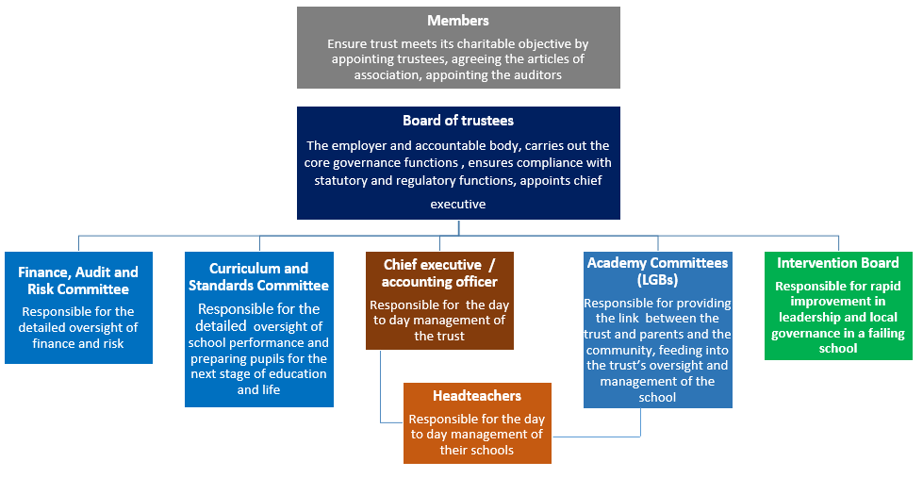

Delegation to hubs / clusters
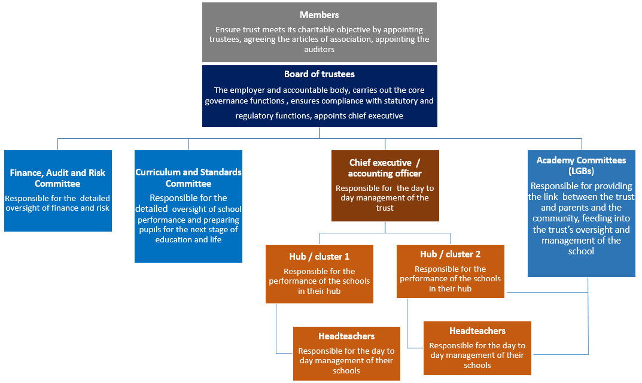

Appendix 2 - Example terms of reference for academy committees (LGBs)
Academy Committee
Example terms of reference
Membership
A minimum of seven and a maximum of nine committee members to include:
- Two elected parents
- One elected member of staff
- Four committee members appointed by the trust, one of whom will be the chair
The headteacher will be in attendance; the clerk will convene and minute meetings

Quorum
A minimum of three committee members appointed by the trust
Meetings
Four meeting a year, two in the autumn term, one in the spring term and one in the summer term
Reporting
Minutes to be submitted to the trust within three weeks of the meeting
Functions
Academy committees are responsible for the link between the trust and the parents and the community, feeding into the trust’s oversight and management of the school. The board delegates to them the following functions:
- Developing an understanding of how the trust and the school are led and managed by:
  - Building an understanding of the trust’s ambitions for the school and its pupils – its vison and strategy and how this is realised at school level
  - Knowing the trust’s values and becoming familiar with key policies, understanding how these work in practice so that they are creating a healthy culture for all
- Being the link with parents and the community by:
  - Building a knowledge of parents’ views and the community context
  - Ensuring that trustees and the CEO are aware of parents’ and community views
- Monitoring the work of the school, escalating any concerns to the CEO and / or trustees by:
  - Scrutinising reports on the school’s progress with achieving its ambitions
  - Scrutinising reports on how the school complies with key policies
  - Visiting the school during the school day and attending events
- Reviewing key decisions made by the headteacher e.g. pupil exclusions and responses to complaints

Appendix 3 - Example of a meeting schedule for academy committees (LGBs)
Example meeting schedule for an academy committee (LGB)
Autumn 1  (early Sept) | Autumn 2  (late in term) | Spring  (mid term) | Summer  (late in term)
Business:  Confirm membership, chair, safeguarding lead  Sign code of conduct  Declare conflicts  Confirm minutes | Business:  Declare conflicts  Confirm minutes | Business:  Declare conflicts  Confirm minutes | Business:  Declare conflicts  Confirm minutes
Reporting:  HT report on:  Initial analysis of public examination results against targets  Update on operational matters (staffing, premises etc.)  Confirm strategy for achieving the vision | Reporting:  HT report on:  Benchmarked validated performance data against national and local figures  Progress towards meeting targets/KPIs, budget and staffing | Reporting:  HT report on:  Mid year progress towards meeting targets/KPIs, budget and staffing  Stakeholder survey results | Reporting:  HT report on:  End year progress  Review of strategy and if it supports the achievement of the vision  Propose targets/KPIs for following year(s)  How budget and staffing will support strategy
Monitoring:  Determine which aspects of improvement strategy and which key policies will be monitored and how | Monitoring:  Committee members to report on monitoring visits | Monitoring:  Committee members to report on monitoring visits | Monitoring:  Review monitoring arrangements and their effectiveness and to begin thinking about strategy for the following year
Community:  Determine interface with the school and agree plan for the year | Community:  Report on community engagement | Community:  Report on community engagement | Community:  Review community engagement and effectiveness, plan strategy for following year
Building knowledge:  Gain an understanding of pupil attainment and progress and performance targets for the year, and how these will be measured | Building knowledge:  SLT to present on a curriculum area | Building knowledge:  HT to lead on:  Review of the school’s SWOT, its vison and ethos, key priorities for achieving the vision, areas of risk | Building knowledge:  SLT to present on how following year’s curriculum will be broad and balanced and prepare students for the next stage of their education or adult life
Training and CPD:  Identify training needs and plan delivery | Training and CPD ongoing  Plan annual conference with trust board for thanks and acknowledgements, information sharing and training

Appendix 4 - Example of an agenda for academy committee (LGB) meetings
Example of an agenda for academy committee (LGB) meetings

 | Item | Lead | Papers | Time
- Business | - Welcome and introductions  - Attendance - to note apologies  - Declarations of Interest - to note  - Appointments and elections - to note  - Urgent items - urgent items must be agreed with the chair in advance of the meeting  - Other business - to agree and sign code of conduct and to discuss the training plan  - Minutes of the last meeting – to agree | Clerk | Code of conduct  Training plan  Minutes | 30 mins
- Reporting | Headteacher’s report  To include:  - Contextual details  - Summary of exam results  - Targets for coming year  - Briefing on the improvement cycle, and the role of the SEF and the SDP  - Policy changes | HT | HT report  SDP  Policy schedule | 60 mins
- Monitoring | - To approve visits’ policy and protocols  - To agree focus for spring term visits | Chair | Policy | 10 mins
- Community | To propose setting up a task and finish group to develop ideas for engaging with parents and the community | Chair |  | 5 mins
- Information | - Meeting dates - to note meeting schedule  - School events - list of events committee members may want to attend | Clerk | Calendar | 5 mins

